- Study the vocabularies of the new lesson (page20- 21) (أَلْبَسُ ثِيَابِي)
- Copy the new vocabs two times each
- Test next week
اسمي:........................... التّاريخ: :.......................
................. , .................... ................. , ....................  ................. , .................... | 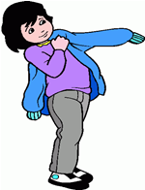  تَـلْبَسُ  Wears
................. , .................... ................. , ....................  ................. , .................... | 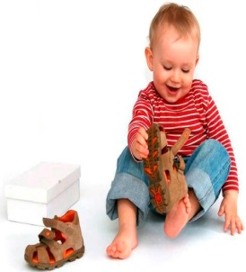  يَـلْبَـسُ  Wears
................. , .................... ................. , ....................  ................. , .................... | 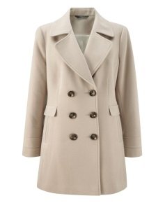  مِعْـطَـف  Coat
................. , .................... ................. , ....................  ................. , .................... | 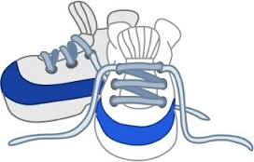  حِـذَاء  Shoes
................. , .................... ................. , ....................  ................. , .................... | جَـوْرَب  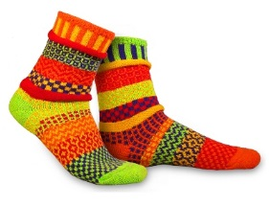  Socks

................. , .................... ................. , ....................  ................. , .................... | 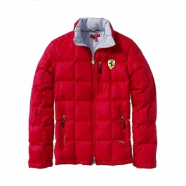  سُـتْـرَة  Jacket
................. , .................... ................. , ....................  ................. , .................... | 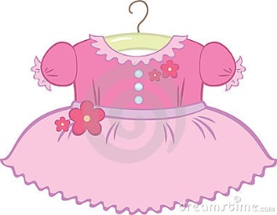  فُسْتَان  Dress
................. , .................... ................. , ....................  ................. , .................... | 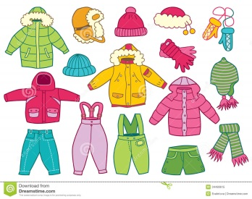  ثِـيَـاب  Clothes
................. , .................... ................. , ....................  ................. , .................... | 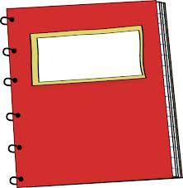  كُـرَّاس  Notebook
................. , .................... ................. , ....................  ................. , .................... | 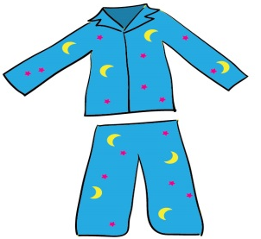  قَمِيصُ النَّوْمِ  Pajamas

